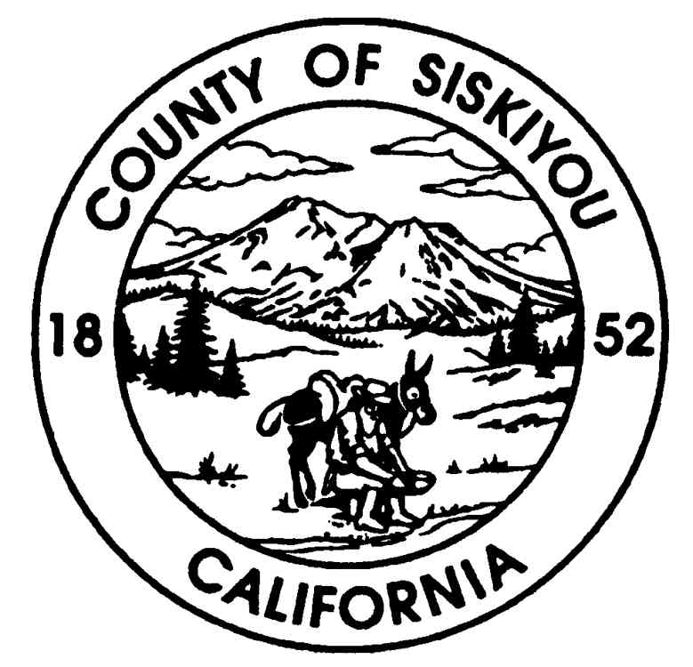**County of Siskiyou**

**County Administrative Office**

**Angela D. Davis, County Administrator**

1312 Fairlane Road, Suite 1, CA 96097

Phone: (530) 842-8005 ● Fax Number: (530) 842-8013

**BOARD REPORT**

To: Members of the Siskiyou County Board of Supervisors

From: Angela Davis, County Administrator

Date: May 2, 2023

Subject: Enhanced Infrastructure Financing District

**Recommended Action:**

It is recommended that the Board take the following actions:

1. Receive a presentation regarding an Enhanced Infrastructure Financing District (EIFD);
2. Consider request by the City of Mt Shasta to enter into a joint agreement Enhanced Infrastructure Financing District; and
3. Provide direction to staff regarding the proposed Enhanced Infrastructure Financing District project to:
   1. Pursue as a joint partner with the City of Mt Shasta; or
   2. Support the City of Mt Shasta as a sole jurisdiction EIFD; or
   3. Recommend annexation of County properties to the City of Mt Shasta.

**Background and Discussion**:

Enhanced Infrastructure Financing District summary:

Tax increment financing (TIF) works by freezing the property tax revenues that flow from a designated project area to the city, county, and other taxing entities at the “base level” in the current year. Additional tax revenue in future years (the “increment”) is diverted into a separate pool of money, which can be used either to pay for improvements directly or to pay back bonds issued against the anticipated TIF revenue.

In California, TIF has historically been used by redevelopment agencies to raise funding for infrastructure improvements, land assembly, housing, and other projects in redevelopment areas. However, redevelopment agencies in California were required by state law to dissolve as of February 1, 2012. In 2014, with Senate Bill (SB) 628 the State revamped existing Infrastructure Financing Districts into Enhanced Infrastructure Financing Districts (EIFDs). EIFDs are a type of TIF district cities and counties could form to help fund economic development projects. Several legislative measures have passed in the years following that modified SB 628 and EIFD requirements: Assembly Bill 733 (2017) allows for EIFDs to fund climate change adaptation projects, including but not limited to projects that address conditions that impact public health (such as decreased air and water quality, temperatures higher than average, etc.) and extreme weather events (such as sea level rise, heat waves, wildfires, etc.); Senate Bill 1145 (2018) allows EIFDs to also fund infrastructure maintenance costs; Assembly Bill 116 (2019) allows for EIFDs to issue bonds without public vote however does increase public engagement requirements.

With these modifications, EIFDs are currently able to fund infrastructure maintenance and housing development, economic development, transportation infrastructure, sewage treatment, and climate adaptation projects, among other uses. EIFDs do not increase property taxes, as they cannot pull property taxes from school districts. EIFDs are governed by a Public Financing Authority (PFA) made up of 5 members of at least 3 elected officials and 2 local community members who live or work in the district area. The PFA oversees the creation of the District’s Infrastructure Financing Plan (IFP), which outlines the specific projects the District will fund. Additionally, while EIFDs are not required to set aside a specific percentage of affordable housing, all housing that is developed must be affordable.

The City of Mt Shasta has expressed interest to the County to create a joint effort EIFD for potential projects in Mt Shasta. Kosmont Companies is the vendor selected via a formal Request For Proposal process to assist with this project. A presentation by Kosmont Companies was given, in which, outlined the project and process and is attached for review. Also attached is the draft EIFD fiscal impact analysis for review.

As noted on page 2 of the presentation, “While a City-only special district strategy would likely achieve favorable “return on investment” for the City, a partnership between the City and County of Siskiyou with emphasis on funding regionally beneficial infrastructure would further improve financial feasibility and long-term positive fiscal impacts for both the City and County general funds”, thus the request by the City to the County to form a joint jurisdiction EIFD.

As noted on page 8 of the presentation, currently, there are four fully formed EIFD’s that are joint jurisdictions that include a city and a county. All four include either Los Angeles County or Orange County and as a result, comparison data is not viable due to their size and urban environment. In addition to the assumptions provided by Kosmont Companies, County Staff conducted additional EIFD research and at this point in time, the finding is that there is a lack of data to analyze the true impact, benefit or otherwise to Siskiyou County. Additionally, annexation of County of Siskiyou properties to the City of Mt Shasta is an alternative option that may be considered and vetted instead of the joint jurisdiction EIFD.

The recommended action options for the Board today, is to: a) Pursue as a joint partner with the City of Mt Shasta; or b) Support the City of Mt Shasta as a sole jurisdiction EIFD; or c) Recommend annexation of County properties to the City of Mt Shasta.

**Fiscal Impact**

The costs associated with this project are unknown at this time due to the fiscal impact analysis is based upon forecasted assumptions and assumed build outs. However, staff time costs need to be considered if the Board directs staff to move forward with the joint jurisdiction EIFD or annexation.

Attachments: EIFD Feasibility Analysis Summary_City of Mt Shasta and County of Siskiyou

EIFD Fiscal Impact Analysis_City of Mt Shasta and County of Siskiyou